**HTML**

**Topic(that I learned)**

**1.Elements**

**2.Tags**

**3.Attributes**

**4.Booleans Attributes**

**5.ID & class**

**6.Document structure**

**7.List**

**8.input types**

**9.Tables**

**10.Select&Option**

**11. Add external Css and js**

**Elements**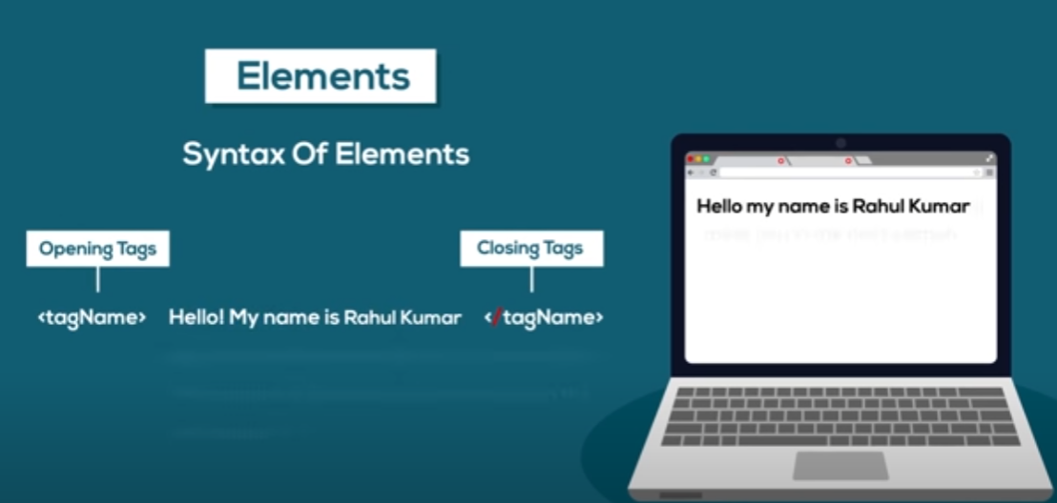

**Code:-**

**Tags**

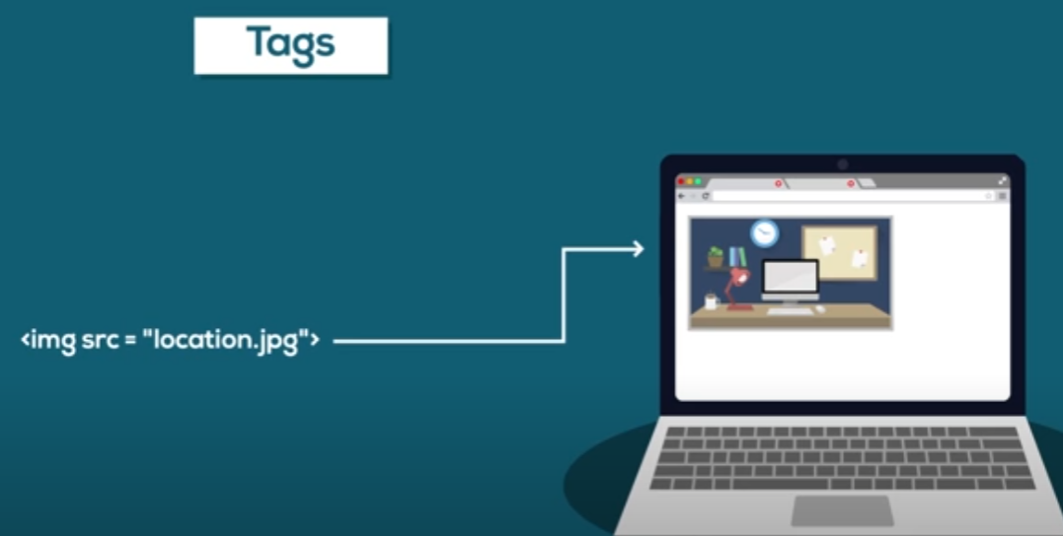

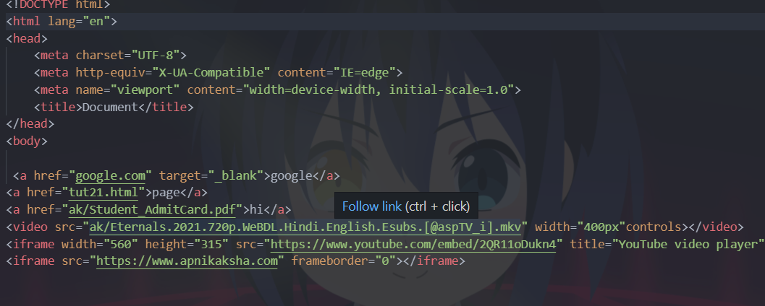

**Attributes:-**

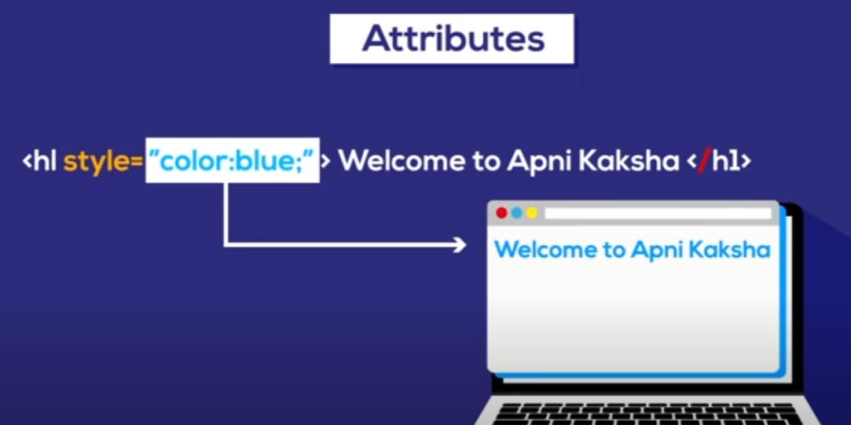

**Example:-**

**Booleans Attributes:-**

**ID &Class:-**

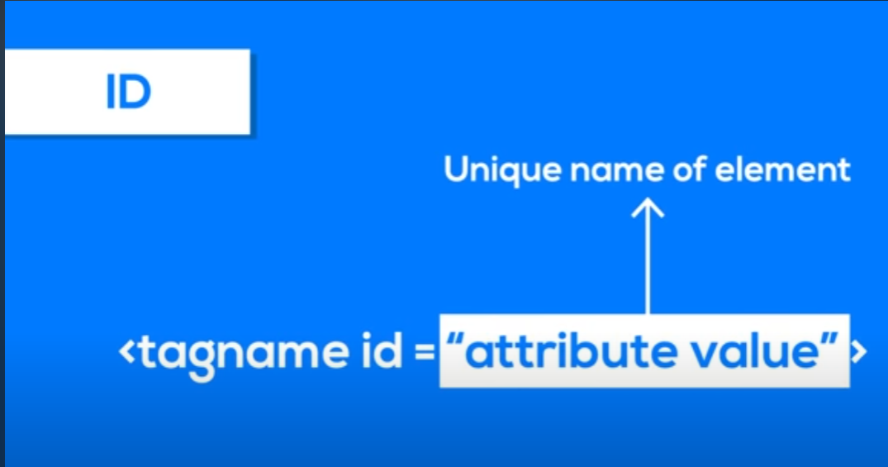

**Document structure:-**

**List:-**

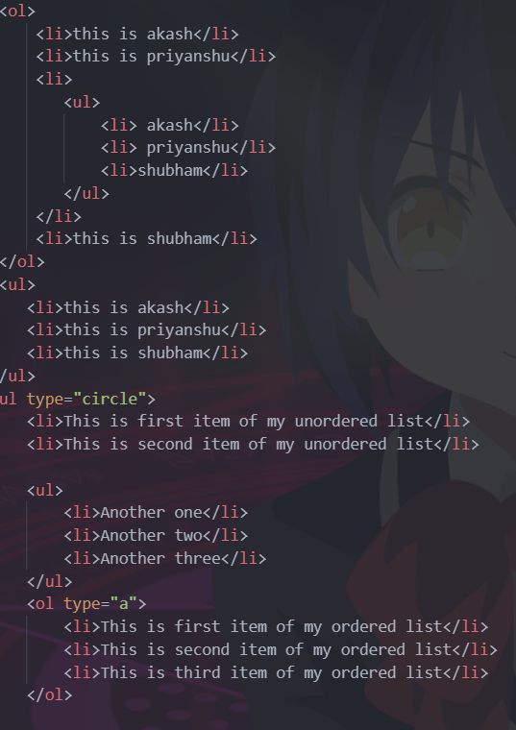

**Input types:-**

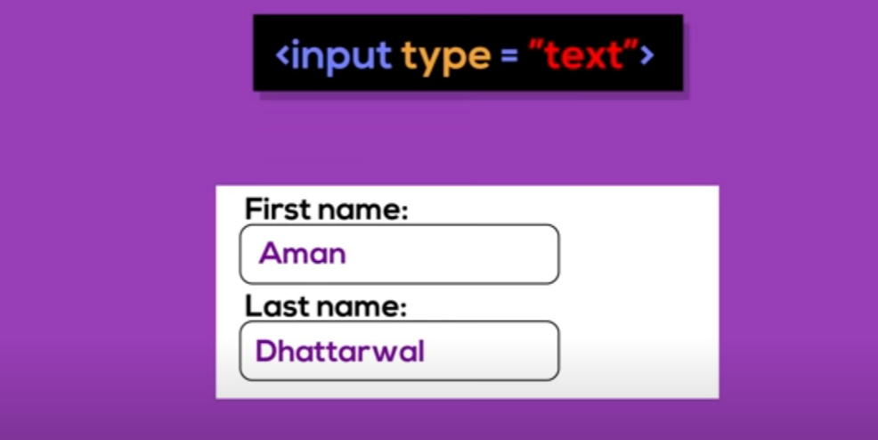

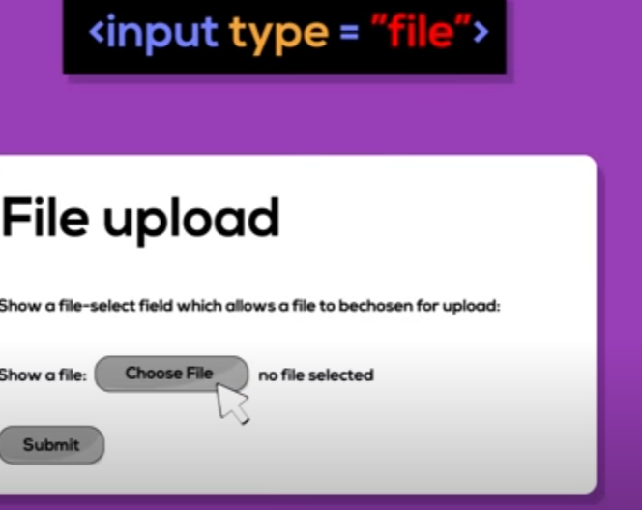

**Tables:-**

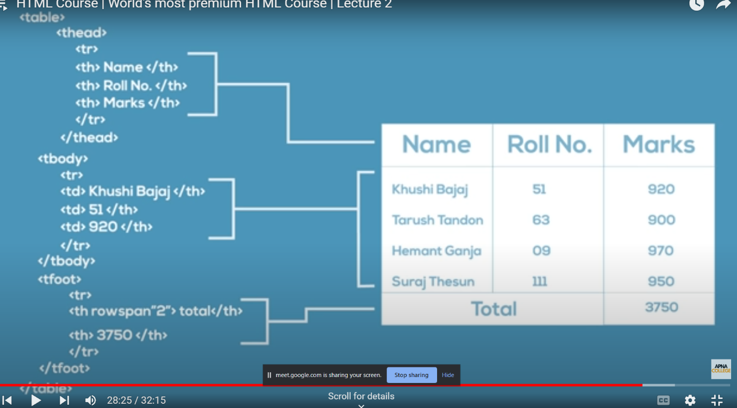

**Select&Option:-**

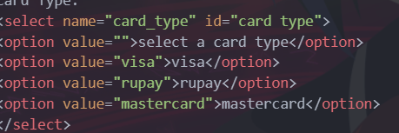

**Add external Css and js:-**

<head>

    <title>Document</title>

    <!-- This is how you include external css -->

    <link rel="stylesheet" href="akash.css">

  <!-- This is how you include external JavaScript -->

    <script src="akash.js"></script>

</head>